22.5/48 = 47%

Lab 5: Human Orrery
Part 1 has no questions; it just has details for setting things up. The questions begin in Part 2.
This lab has a total of 48 points.

Part 1: Setup
For this lab, you will be walking around in a large room (or outside), as described above. We will be simulating how the Sun and stars look from Earth.
First, we need a Sun. Get an object to represent the Sun, and place it in the middle of the room – preferably on a raised platform of some kind, like a chair, stool, or table. It doesn’t matter what object you use for the Sun, as long as you can easily see it. A yellow ball or a lamp would be nice, but a water bottle will work just as well.
Next, we need to put up the stars. There is a PDF document associated with this lab, consisting of a bunch of constellations – officially identified star patterns. The whole sky is divided into 88 constellations, but here we will be using only 14. The first 13 constellations in the PDF are a little special: they are the ones that the Sun passes through over the course of a year.
You can print out the PDF (single-sided!) and place the constellations as described below. If you don’t want to print it out, you can draw them yourself on pieces of paper (like I’ve done below). You don’t have to carefully draw the stars within each constellation; just be sure that you can tell what constellation you’re looking at from across the room. You could even use random objects instead (say, a coffee mug for Virgo or a picture on the wall for Libra), as long as you remember which constellation is which.
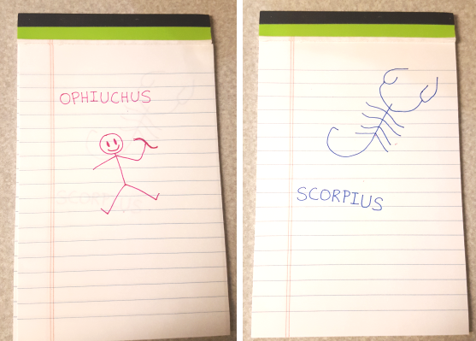
Whatever form your constellations are, place them about the room so that they won’t flutter around as you do this lab. For constellations on paper, I recommend either taping them to the walls, or putting them on the ground with small items to hold them down.
Below are a table of the 13 constellations the Sun can be seen passing through, and a diagram showing where they should be around the room. We’re already cheating a little bit here: the real constellations vary quite a bit in size – for example, Virgo takes up a wider swath of the sky than tiny Cancer. But spacing them at equal distances from each other will be fine, as long as they’re in the correct order.
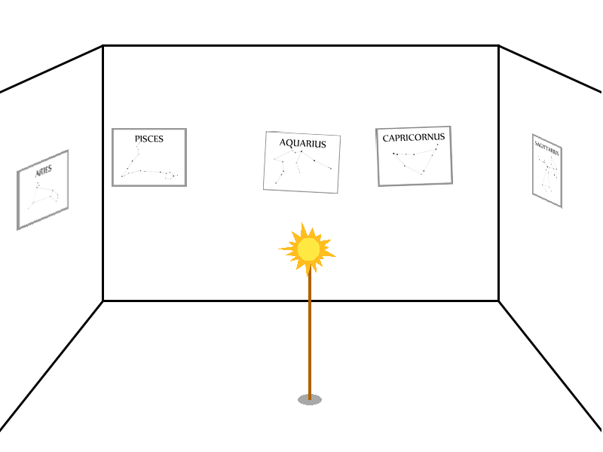

the water carrier | Aquarius | Aqr
the sea-goat | Capricornus | Cap
the archer | Sagittarius | Sgr
the serpent holder | Ophiuchus | Oph
the scorpion | Scorpius | Sco
the scales | Libra | Lib
the virgin | Virgo | Vir
the lion | Leo | Leo
the crab | Cancer | Cnc
the twins | Gemini | Gem
the bull | Taurus | Tau
the ram | Aries | Ari
the fishes | Pisces | Psc

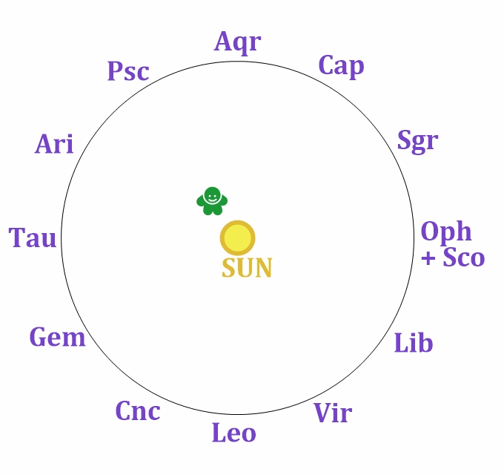
Also note that Ophiuchus and Scorpius are in about the same place. Put Scorpius below and slightly right of Ophiuchus.
Orion is a famous constellation, and if you want you can put him up too – he should go below this ring of thirteen constellations, somewhere between Gemini and Taurus.
(You could imagine what it would be like if we included all the other constellations in the sky – they’d go above and below this set so they’d wallpaper the whole room. For example, Cassiopeia would end up on the ceiling kind of near Aries, Cygnus would be above Aquarius, and the Southern Cross would go on the floor near Libra/Virgo.)

Lastly, we need the Earth. You will be the Earth. For the start of this lab, Earth will be located between the Sun and the stars that make up the constellation Pisces, so go stand there. (Ideally you should be much closer to the Sun than to the walls, since the distances to the stars are far larger than Earth’s distance from the Sun. But that may or may not be possible with the room you’re in, so just do the best you can.)
As the Earth, the North Pole will be the top of your head, and the South Pole the bottoms of your feet. Las Vegas will be smack dab in the middle of your chest, and the equator will be your belt.
The Sun isn’t visible 24 hours a day, so our sky-watcher in Las Vegas will need a horizon. Stretch out your arms to make a T shape. Everything in front of your arms is above the horizon, and therefore up in the sky. An observer in Las Vegas cannot see anything below the horizon (behind your arms) because there is an Earth in the way.
One of your hands will be the eastern horizon, and one will be the west. Going west on the globe is like going from your chest to your right hand. So your right hand is West, and your left hand is East. You may want to give yourself a reminder: perhaps write a W and E on scraps of paper for you to hold, or write them directly onto your hands.
North is toward the top of your head (the North Pole) and south is toward your feet (the South Pole), but we won’t be using those directions.
Note that these directions are for Las Vegas (your chest) only. For example, someone in the Azores (an island group in the Atlantic) would be located on your left side. For them, “west” would be your right arm pointing ahead of you, and “east” would be your left arm pointing behind you.

Part 2: One Day (12 points) 7/12
Here the questions will begin. At the start of this lab, you should be standing between the Sun and the constellation Pisces, which is roughly where Earth will be in its orbit around the start of October. When I ask about times, general answers like “6 am” or “noon” will be fine. Just be sure you’re clear whether you’re talking about AM or PM!
Okay, let’s simulate one full rotation. First, turn in place so that Las Vegas (your chest) is pointed toward the Sun. Imagine what a tiny person in Las Vegas would be seeing in the sky.
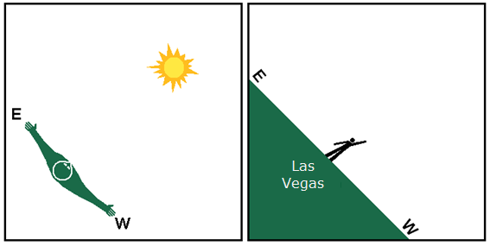
For Las Vegas, the Sun is at its highest point for the day. What time is it in Las Vegas when the Sun is doing this? (1 point)

Noon
Now turn in place so that you are facing directly away from the Sun. Now Las Vegas cannot see the Sun – it is halfway between sunset and sunrise. What time is it? (1 point)
Midnight
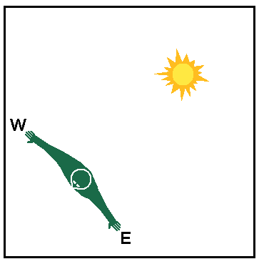

Let’s look at the two times that are halfway between the ones we looked at. We know that the Sun rises in the east, and sets in the west. Turn so that your left hand (East) is pointed toward the Sun. Now in Las Vegas, the Sun is rising in the east. We are halfway between the two times you wrote above, around sunrise. About what time is it in Las Vegas now? (1 point)
6am
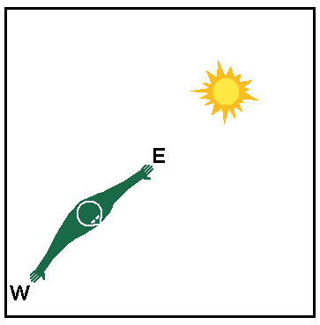

And finally, turn so that your right hand (West) is pointed toward the Sun. Now in Las Vegas, the Sun is setting in the west. Again we are halfway between the times in #1 and #2, but now around sunset. What time is it? (1 point)
6 pm
We have just seen how to stand so that the Sun is rising, high up, setting, and not visible. So now you should be able to piece together which direction to turn to correctly mimic Earth’s rotation. If someone were looking down on you from above (in other words, looking down on the North Pole), would they see you/Earth spinning clockwise, or counter-clockwise? (1 point)
Counter-clockwise
As the world turns, which part of the United States is the first to see the Sun rise: the east coast, or the west coast? (1 point)
East Coast
Spin around once. On Earth, how long does it take for the Sun to return to the same place in the sky like this? (1 point)
24 hours
There was a 5-point question here asking you to submit a photo of your setup.

Part 3: One Day, continued (13 points) 2/13
Oh look, there are stars in the sky. If the Sun is up (in front of the horizon made by your “East” and “West” hands), a sky-watcher won’t be able to see the stars, but they’re still there. The Sun just makes the sky too bright to see them. (Go ahead and revisit the setup instructions if you forget where you’re supposed to be standing now.) If we dimmed the Sun and sky enough to see the background stars, you could tell which constellation is behind the Sun. For short, let’s just say that the Sun is currently in that constellation.
(If you were in the midst of a solar eclipse, the moon would be blocking out the Sun’s light, and you could see the stars behind them.)
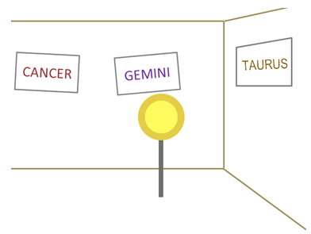
For example, if from your current position you see a view like the one shown above, you’d say the Sun was in the constellation Gemini, since Gemini is behind the Sun.
At the moment, you should still be standing between the Sun and the constellation Pisces, so your actual view will probably not look like the picture above.

Let’s consider the sky at sunset. Make sure you’re standing in the spot where you started this lab, and turn in place so that it’s sunset in Las Vegas (the Sun is at your west/right hand). The constellation your chest is currently facing will be high up in the sky for viewers in Las Vegas. Which constellation is that? (1 point)
Leo
If you’re standing between the Sun and Pisces, with your right hand to the Sun, then your chest should be facing Sagittarius or Capricornus. 0/1

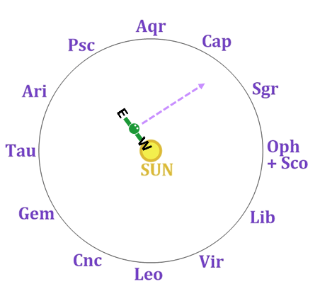

Without turning the Earth (still keeping it sunset in Las Vegas), glance over toward the Sun. Note the constellation that’s on the wall in that direction. Which constellation do you see behind the Sun? (1 point)
East 0/1

Let’s rewind the day a little bit. Turn in place so that it’s “high noon” in Las Vegas. Which constellation is behind the Sun now? (1 point)
West 0/1

Would sky-watchers in cities elsewhere on the globe give the same constellations for what’s up at (their) sunset, and what’s behind the Sun at (their) sunset and noon? (1 point)
Since we are observing them from such a great distance, the stars in a constellation appear to be on the same plane. I don’t understand how this answers the question. 0/1

Now slowly spin around in place (in the correct direction – see #5) and pay attention to which constellations are “up” for Las Vegas and when. Sometimes a constellation will be high up in the sky, sometimes it will be just barely above the horizon (barely in front of one of your hands), and sometimes it won’t be up at all. Remember, any part of “the sky” that is in front of your outstretched arms would be visible from Las Vegas. Fill in the blanks with compass directions: As you turn through one day, the constellations appear to rise in the __east_____ and set in the __west____. (1 point)

Spin around so that it’s now midnight in Las Vegas. Out of the 13 constellations we’ve put up on the walls, which ones are above the horizon for our sky-watcher in Las Vegas? (If we divided the sky/room into two halves – half in front of the line made by your outstretched arms and half behind that line – they’d be the ones in front.) (1 point)
Leo
You’re standing between the Sun and Pisces. So when it’s midnight in Las Vegas – your back is to the Sun – the half of the room in front of your outstretched arms will be the half centered around Pisces: Taurus, Aries, Pisces, Aquarius, and Capricornus. And maybe Gemini and/or Sagittarius. 0/1

Out of the constellations you gave for the previous question, which one is highest up in the sky for Las Vegas? (It would be whichever one your chest is directly pointing at.) (1 point) 0/1

Spin around so that it’s sunrise in Las Vegas. Now locate the constellation from your previous answer. Where in the sky (high up, low in the east, low in the west) would that constellation be at sunrise? (1 point)
To the right low in the west 0/1

Spin around so that it’s sunset in Las Vegas. Where in the sky (high up, low in the east, low in the west) would that constellation be at sunset? (1 point)
To the left low in the east 0/1

Let’s go back to the constellation(s) where the Sun is located.

Which constellation is its neighbor to the left (east)? (For example, if our view was the one seen in the picture from the start of Part 3, with the Sun in front of Gemini, then the constellation just to the left of it would be Cancer.) (1 point)
Virgo

Is there any time today when someone could see that constellation? That is, a time when that constellation is up (it’s in front of the line made by your outstretched arms), but the Sun isn’t (it’s behind your outstretched arms). Explain your answer, using complete sentences. (1 point)
You would be able to see it if the Sun wasn't too high in the sky to obscure it. It all depends on where you are in the globe. It should be visible in Winston-Salem.

Which constellation is just to the right (west) of the Sun’s location? What time of day would you be able to see it (if at all)? (2 points)
Aries
The Sun is currently in front of Virgo. Virgo’s next-door neighbors are Libra and Leo. Virgo is in the same direction as the Sun, so it has the same rise/set schedule as the Sun. Libra and Leo are not in the exact same direction as the Sun, so their schedules that are slightly different. Libra rises and sets a little after the Sun does, so it would be visible for a short window right after sunset. Leo rises and sets a little before the Sun does, so it would be visible for a short window right before sunrise. 1/4

Part 4: One Year (14 points) 7.5/14
So far you have been spinning around, but not moving about the room. Now let’s see what happens as the Earth travels in its orbit around the Sun. Normally, the Earth spins around 365 times for every full orbit… but we won’t have you do that. I don’t want you to get dizzy.
Make sure you’re standing in the correct part of the room, as described earlier.

As seen from someone looking down upon the North Pole (the top of your head), the Earth travels around the Sun counter-clockwise. Turn in place so that you’re facing the Sun, and start side-stepping rightward around it until you see a different constellation behind the Sun.
Which constellation is the Sun in front of now? (1 point)
Aries

From this new location in Earth’s orbit, which constellation is highest up at midnight? (Turn in place so that it’s midnight, then look at which constellation your chest is now facing.) (1 point)
Libra
At the start, you should’ve been standing between the Sun and Pisces. Since then, you’ve moved counter-clockwise 1/12 of the way around, so now you should be standing between the Sun and Aries. Libra is now behind the Sun, and Aries is now high up at midnight. 0/2
Now that we are a little later in the year, let’s consider another day. Turn in place, and see when the constellations we looked at before rise and set. Do the constellations rise and set at earlier times than before, or later? (1 point)
Later
Earlier. Let’s take Virgo as an example. Before, Virgo was the constellation behind the Sun, so it would rise at sunrise and set at sunset. In your new position, as you spin in place counter-clockwise, you should now see Virgo rise a little bit before the Sun rises, and set a little before the Sun sets. 0/1
We began this lab where Earth is around the start of October.
These last three questions showed us what things will be like a month from now, at the start of November.
Let’s go through a whole year.
Fill out the following table. For the dates below, which constellation is the Sun in? Which constellation is high up at midnight?
We’ll start with October 1st, which is where you were standing at the start of the lab. Your answers for the first row should be what you got back in Part 3.
For the other three dates, continue in your orbit around the Sun; they are each another 1/4 of a full loop. (In other words, for January 1, go two months further around from your current position. For April 1, move another quarter of the way around after that. If you make it all the way to the start of October 2022, you should be back where you were for October 2021.)
(8 points total)
date | the Sun is in… | high up at midnight
October 1 | libra | Aries
January 1 | Capricornus | Cancer
April 1 | Aries | Libra
July 1 | Cancer | Capricornus
Aside from starting in the wrong place – the first row should be Virgo and Pisces – you followed the right process for filling out this table. 6/8
Now that you know which locations in Earth’s orbit correspond to which times of year, let’s try things out a bit.
For these next few questions, the table above (along with some of your earlier answers like #27) should provide enough information to figure things out, but you can also figure them out by continuing to act out Earth’s orbit.
During the start of which month would Scorpius be high up at midnight? (1 point)
July According to your table, it’d be around May – between when Libra is high up at midnight, and when Capricornus is (but closer to Libra). 0/1
During the start of which month would Gemini be high up at midnight? (1 point)
January According to your table, it’d be December – between when Aries is high up at midnight, and when Cancer is (but closer to Cancer). 0.5/1
The constellation Orion lies below the Sun’s path through the sky, roughly between the constellations Gemini and Taurus. When during the year would Orion be high up at midnight? (1 point)
November
In myth, the mighty hunter Orion angered the gods, so they sent a scorpion to kill him. After the deed was done, both were put up in the sky, but at (roughly) opposite ends because they didn’t like each other very much.

Part 5: Wrap-up Questions (9 points) 6/9
Below is a map of the celestial sphere. More northerly declinations are higher up in this map, and declinations that are further south are lower in the map. The celestial equator runs through the middle, but may be hard to see. The ecliptic – the Sun’s apparent locations relative to the background stars, as seen from Earth – is the blue line. The 13 constellations with territory on the ecliptic are labeled. (We can also see the Milky Way in light blue.)
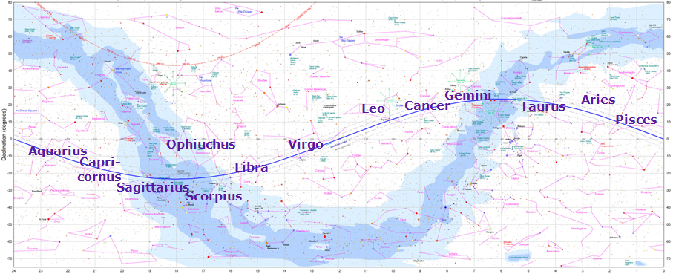
Think back to how an object’s location in the celestial sphere is related to how long it remains above the horizon for Las Vegas. At the time of year when the Sun is up for the longest amount of time per day, which constellation is it in front of? (1 point)
Which constellation is the Sun in front of, at the time of year when it spends the least amount of time above Las Vegas’s horizon? (1 point)
Explain your answers for the previous two questions. (1 point)
0/3
Let’s say I go look at the sky tonight at 9pm. A couple hours later, I go back outside and see that the constellations have moved a little bit. What is the main reason for this? Use complete sentences. (1 point)
The stars set in the west just like the sun does. In this regard, as the earth rotates, they will be seen going west.

I go outside and look at the night sky at 8:15 PM on January 15. I go out again at 8:15 PM on February 15, and see that the constellations are in different places. What is the main reason for this? Use complete sentences. (1 point)
The Earth's orbit around the Sun causes star positions to shift. The constellations shift a little each day, so it won't be in the same spot in a month.

We have seen that the constellations seem to “move” a little bit each day, over the course of a year. When the Earth returns to the same place in its orbit, the constellations have returned to their original places.
If you’re a careful observer, you’ll notice that the constellations rise and set at a slightly different time each day. Let’s figure out just what this time change is.
Will tomorrow night’s constellations rise and set a few minutes earlier or a few minutes later than they did today? (If you’re not sure, look back to Part 4.) (1 point)
They will rise and set a few minutes later (earlier)
For them to return to their original starting places after one year, the constellations’ rising time will have to “drift” by 24 hours over the course of one year. If they drift at a constant rate, then the drift after one day will be 1/365 that amount. (3 points total)
24 hours is how many minutes:
1,440 minutes
Divide your previous answer by 365. By how many minutes do the constellations’ rise/set times change from one day to the next?
4 minutes
Let’s say I go out to observe the sky at 10:00 PM tonight. Based on the answers above, if I want to see the stars in the exact same positions tomorrow night, at what time should I go out?
9.56 pm

